Torment Card Preview: Circular Logic
Andrew Johnson
Monday, January 21, 2002
In a sea of black, there is at least one blue gem. With an interesting casting cost and card type, an instant for , and of such stuff great cards are made. From the venerable Psionic Blast, to Extended-dominating Intuition, to the Exclude and Repulse so popular in Standard, a instant is a recipe for a good card. This one would prove to be no exception.
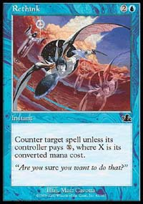
The card in question is aptly named Circular Logic. The card is prone to Limited play and Block play, much like its cousin Rethink. Rethink saw play in Nether-Go in Masques Block Constructed, and a fair amount of play in Limited as well. It made a few appearances in Counter-Rebel in Standard, when the rebel deck sought to minimize the number of blue sources it needed. Under normal circumstances, this card would be nothing newsworthy. It would be just another mediocre Counterspell, albeit very nice in the permission light Odyssey Block.
What makes this card special is its final line of text: Madness . The card suddenly turns from barely playable to a superstar across many formats. Not only does the card have a reasonable ability without having to activate its Madness, it becomes an insanely cheap counter if you build your deck accordingly. Let's consider the ramifications of the card across various formats, starting with Odyssey Block Constructed.
Preliminary testing of Block Constructed shows that the Upheaval decks are exceedingly dominant, in green and black varieties. To activate its combo against decks using blue, the Infestation Upheaval deck can just pitch the Logic for free to an Infestation played earlier. This means that the 8-mana combo can be supported by a one-mana counter; moreover, versus the aggressive decks, the Upheaval deck can generate a Zombie and Counterspell something for just two cards and one mana. The green Upheaval decks can also utilize the card with Wild Mongrel. An inspection of Odyssey reveals a list of cards that stand nicely on their own that combo nicely with Circular Logic: Zombie Infestation, Wild Mongrel, Rites of Refusal, Resilient Wanderer, Psychatog, Patrol Hound, Patchwork Gnomes, and Cephalid Looter. Obviously, some of these cards aren't the greatest, but they all merit consideration in such a limited field. Rites of Refusal bears a bit of explaining. By pitching the Logic to the Rites, one can easily ensure winning a counter war with this double counter combo for just three mana. Beyond just the Odyssey cards, who can tell what surprises in Torment will bolster this card as staple permission of the format? We have had a brief glimpse in Alex Shvartsman's earlier article on Compulsion, but many more surprises are in store.
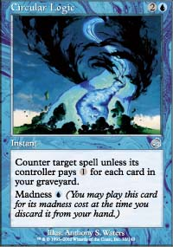
Most of the material mentioned earlier applies to Limited as well, just on a rarer occasion. The fact that Circular Logic is playable even without madness though will make it a contender in Limited, despite the makeup of one's deck.
Beyond Block though, we find even deeper options for abusing the madness of Circular Logic. Inspection of instants show cards like Firestorm, which could allow you to simultaneously devastate the opposing army and the opposing stacked spells. Like Rites of Refusal, Foiling with Logic provides the same double counter-weapon in a permission war, but cheaper. Circular Logic fits almost effortlessly into the now-dominant Miracle Grow, whether it be a variety that utilizes Mongrels, Waterfront Bouncers, or Looters. Maybe Frantic Search will even see some play now with all the madness running around. IF it weren't for his hatred of blue, Jamie Wakefield would revel in the synergy between Circular Logic and Mindless Automaton. We can even see ripples of Logic into Kurt Hahn's brainchild of 5-Color. After all, how busted is Circular Logic with Dream Halls?
All these snippets though are mere fragments of the past. In a set centered around madness, one cannot but wonder all the avenues for abuse that Circular Logic entails. I guess we shall just have to see what dreams may come.
Torment Prerelease info can be found here.

